**Money:**

Medium of exchange: an object that is generally accepted in exchange for goods and services.

Barter: exchange goods and services directly

Unite of account: an agreed measure for stating the price of goods and services

Store of Value: can be held for a time and later exchange for goods and services

**Money in Canada consists of:**

Currency: the notes and coins held by individuals and businesses

Deposits at banks and other depository institutions

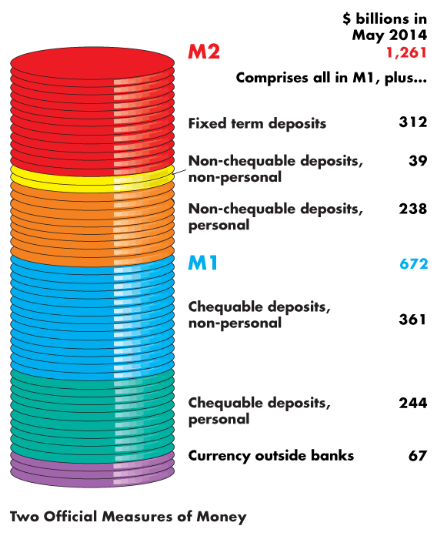Official Measures of Money:

M1: currency and chequable deposits own by individuals and businesses

All items in M1 are money

M2: M1+all other deposit-non-chequable deposits and fixes term deposits

Some savings deposits in M2 are not means of payment – liquid assets

Liquidity: Property of being instantly convertible into a means of payment with little loss of value

Deposits: money

Cheques: not money, it is an instruction to a bank to transfer money

Credit cards: not money, enables the holder to obtain a loan which must be repaid with money

Depository Institution: a firm that takes deposits from households and firms and makes loans to other households and firms.

1. Chartered banks : private firm
2. Credit unions and caisses popularise: cooperative organization
3. Trust and mortgage loan companies

Interest rate: lands < pays

Loans generate profit, but depositors must be able to obtain their fund when they want them

Depositors’ fund:

1. Reserved – notes and coins in its vault or its deposit at the bank of Canada
2. Liquid assets – Canadian government Treasury bills and commercial bills
3. Securities – longer term Canadian government bond and other bonds such as mortgage backed securities
4. Loans – commitments of fixed amounts of money for agreed upon periods of time

Benefits of depository institutions:

1. Create liquidity
2. Pool risks
3. Lower the cost of borrowing
4. Lower the cost of monitoring borrowers

Financial innovation:

Aim: lower the cost of deposits and increase the return from lending

Influenced by 1) Economic environment 2) Technology

Central Bank: the public authority that regulates a nation’s depository institutions and control the quantity of money

Bank of Canada: the central bank of Canada

1. Banker to banks and government accepts deposits from depository institutions that make up the payment system and the government of Canada
2. Lender of last resort: it stands ready to make loans when the banking system is short of reserves
3. Sole issuer of bank notes: the only bank that is permitted to issue bank notes. (monopoly)

On the Bank of Canada’s balance sheet, the largest and most important asset is Canadian government securities and the most important liabilities are Bank of Canada notes in circulation and banks’ deposits, which forms the monetary base.

Monetary base: the sum of Bank of Canada notes outside the Bank of Canada, banks’ deposit at the Bank of Canada, and coins held by households, firm and banks.

Policy tools to change the monetary base:

1. Open market operation: the purchase or sale of government securities by the Bank of Canada from or to a charted bank or the public. Securities<==>Reserves
2. Bank rate: the interest rate when making short-term loans to major depository institutions

Factors that limits the quantity of deposits that banks can make:

1. The monetary base: the sum of Bank of Canada notes coins and banks’ deposits at the Bank of Canada.
2. Desire reserves: notes and coins in its vault and its deposit at the Bank of Canada.

Desire reserve ratio: bank’s reserves/total deposits that a bank plan hold

1. Desired currency holding: currency drain ratio = ratio of currency to deposit

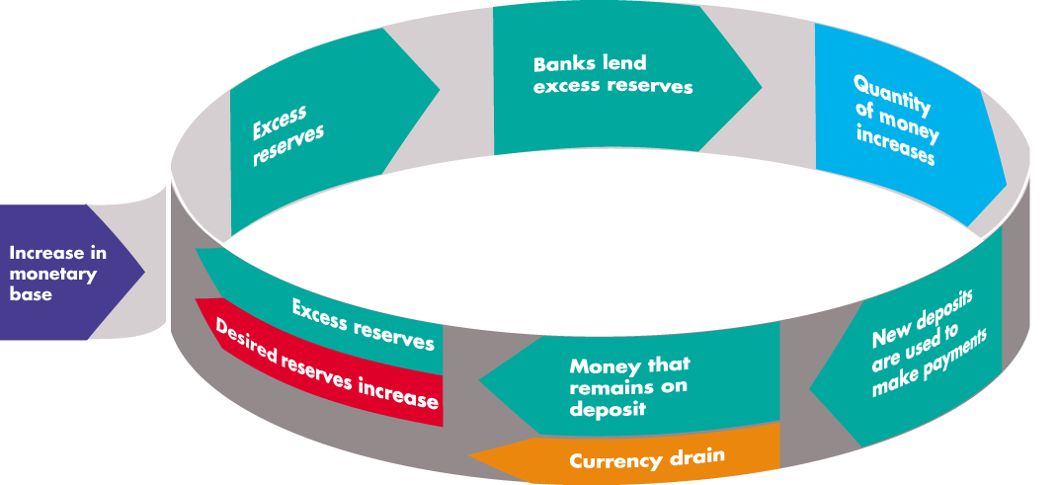Money creation process => increase in the monetary base

Excess reserves = Actual reserves – desired reserves

Money multiplier: change in the quantity of money/change in the monetary base

Factors that depends the quantity of money people plan to hold:

1. The price level: up, increase the quantity of nominal money, doesn’t change the quantity of real money.

Nominal Money: the amount of money measured in dollars

Real Money: Nominal Money/Price Level

1. The nominal interest rate: the opportunity cost of holding wealth in the form of money rather than an interest-bearing asset
2. Real GDP: up, increase the quantity of real money that people plan to hold
3. Financial innovation: lower the cost of switching between money interest-bearing assets and decreases the quantity of real money that people plan to hold

Demand for money: the relationship between the quantity of real money demanded and the nominal interest rate when all other influences on the amount of money that people wish to hold remain the same

Short-term money equilibrium The Short-Run Effect of a Change in the Quantity of Money

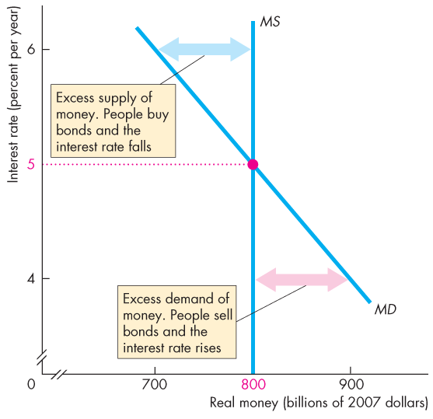

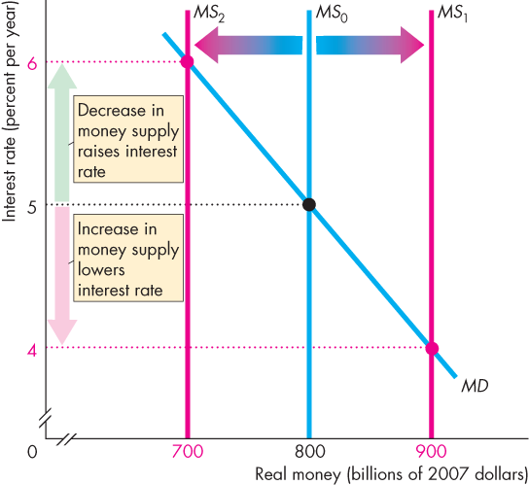

In a long run:

1. The loanable funds market determines the real interest rate.
2. Nominal interest rate = equilibrium real interest rate + expected inflation rate
3. Real GDP = Potential GDP